## horizontal line



Deep learning based segmentation of remote sensing imagery to identify LULC

**─**

Modi Omkar - 19EE30018

Piyush Kumar - 19IE10022

Yash Anup Vora - 19MF10038

Mansi Uniyal - 19EE10039

Praveen Yadav - 19MF

# Introduction

There has been a drastic growth of artificial intelligence over the years. Machine Learning has played a key role in changing the lives of many by advances that make life easier. They are involved as key decision makers by analyzing trends over time, statistically interpreting the data, and predicting the future. Deep learning is a machine learning technique that teaches computers to do what comes naturally to humans with the help of neural network architectures. It acts as the key technology behind driverless cars, medical image diagnosting, remote sensing, object recognition, and many more. Here in this project we will be focusing on the various aspects of deep learning methods for Image Segmentation, and its application in Remote Sensing.

Semantic image segmentation is to label each pixel of an image with a corresponding class of what is being represented. Because we're predicting for every pixel in the image, this task is commonly referred to as dense prediction. One important thing to note is that we're not separating instances of the same class; we only care about the category of each pixel. In other words, if you have two objects of the same category in your input image, the segmentation map does not inherently distinguish these as separate objects. Segmentation models are useful for a variety of tasks, including:

1. Autonomous vehicles:-

We need to equip cars with the necessary perception to understand their environment so that self-driving cars can safely integrate into our existing roads.

1. Medical image diagnostics:-

Machines can augment analysis performed by radiologists, greatly reducing the time required to run diagnostic tests.

1. GeoSpatial Remote Sensing:-

Tracking clouds to help predict the weather or watching erupting volcanoes, and help watch for dust storms.

Urban planning (like, building and road mapping), and Tracking the growth of a city and changes in farmland or forests (concerns like, deforestation, natural water resource) over several years or decades. Large forest fires can be mapped from space, allowing rangers to see a much larger area than from the ground.

Discovery and mapping of the rugged topography of the ocean floor (e.g., huge mountain ranges, deep canyons, and the “magnetic striping” on the ocean floor).

# Challenges

# Dataset

The mask file contains more than 5 classes by default. We need to only detect vegetation class.

# Methodology

## Analyzing and Visualizing

Our goal was to detect vegetation class. Therefore, we created a new mask which contains information about vegetation(0) and non-vegetation(1). The figure belows shows the image with its corresponding mask image for training purposes.

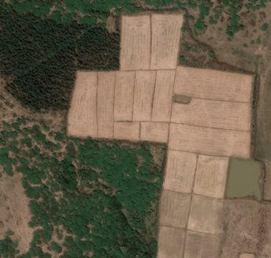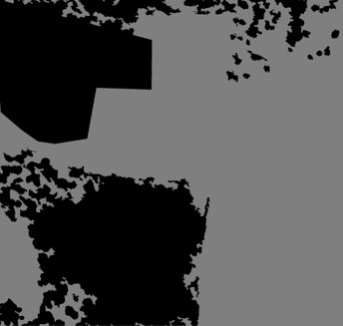

## Preprocessing

The satellite images were of large dimensions (1948 x 2048), we split it into 16 smaller parts with the same dimensions (487 x 512) and then resized it to 160x160​.

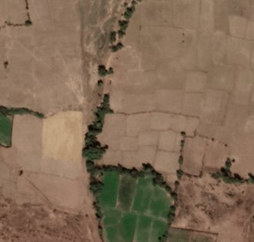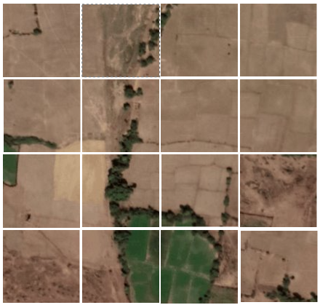

## Model

After reading papers and seeing some practical examples on it, we realized that CNN based U-Net Architecture gives astounding results on biological images segmentation and in radio astronomy.​ We believe our dataset is somewhat similar to these where there are a lot of things belonging to different classes present in one frame with a significant amount of noise. ​The figure below depicts the U-Net model architecture that has been used in the project.

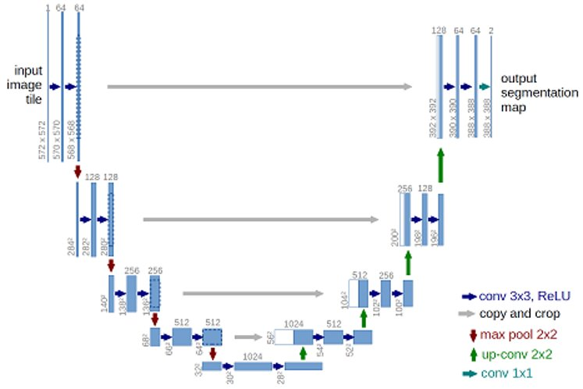

The model took an average running time on the CPU is 25-30 minutes per epoch, and was trained for a total of 25 epochs. The model was compiled with an optimizer as "rmsprop", loss function used was "sparse_categorical_crossentropy".

Root Mean Squared Propagation, or RMSProp, is an extension of gradient descent and the AdaGrad version of gradient descent that uses a decaying average of partial gradients in the adaptation of the step size for each parameter.

Sparse_categorical_crossentropy is used as a loss function for multi-class classification models where the output label is assigned integer value (0, 1, 2, 3…). This loss function is mathematically the same as the categorical_crossentropy. It just has a different interface.

# Results

The U-Net model is trained for 25 epochs with a train test split of 640 validation dataset to a collection of __ training dataset. The training of the model shows that it neither overfits nor underfits the training set. The figure below shows the Learning curves for Loss and Accuracy calculated which denote as evaluation metrics for training.

Below are some of the predicted results that are obtained on the test data. The smaller patches of the test data are re-patched to obtain the final concatenated mask image.

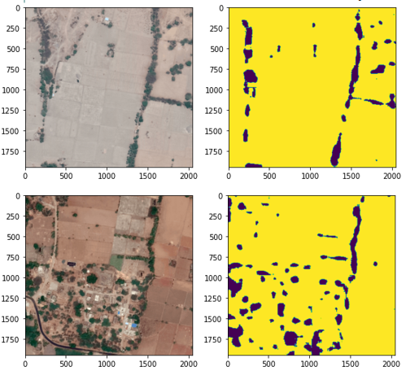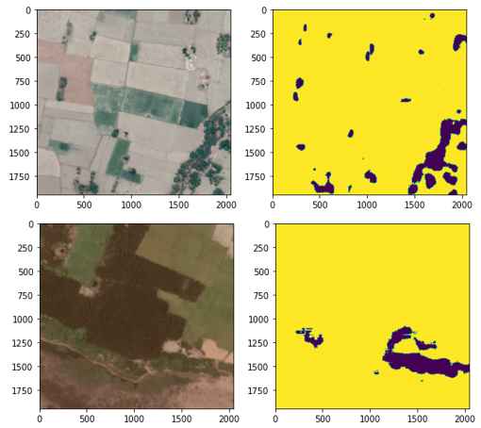

# Conclusion